**Reusability in Ansible**

Import playbook option: Here by using the import tag, we can import a playbook.

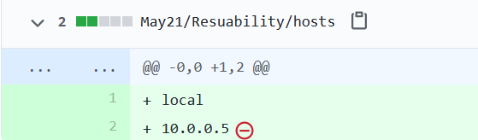

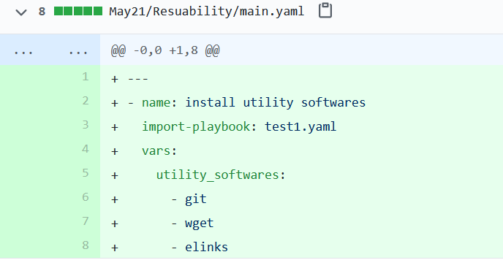

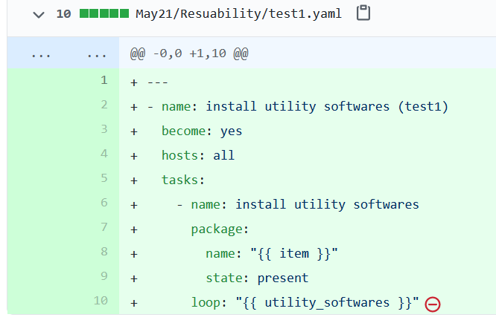

Tags in Ansible

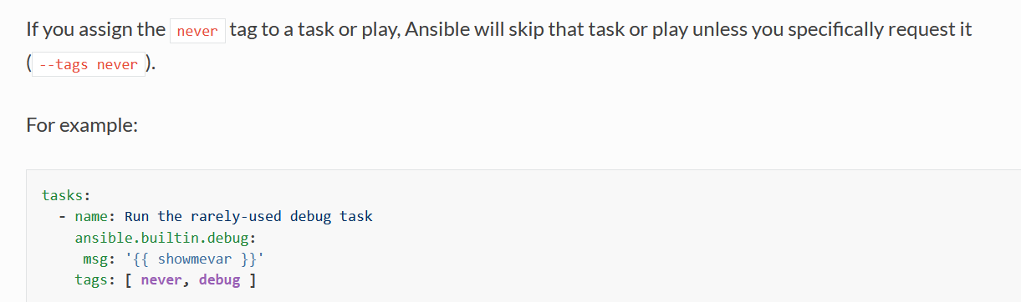

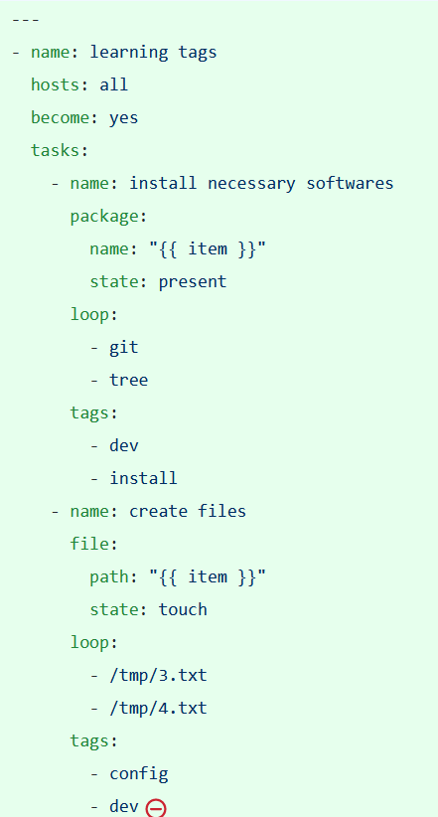



You may skip the tag by skip tag option.